
E-safety report to governors – October 2018
Report written by Mrs J Lea
There have been no incidents regarding e-safety (safeguarding) this year that have needed to be recorded by the authority.
The technician in school maintains the filtering software well and all updates are carried out as needed to keep children safe.
Children continue to learn about e-safety through our curriculum and follow the rules that we have decided as a school.
As part of my performance management this year I am providing information to parents on the newsletter each half term regarding how to help keep children safe while using the internet and this will also help parents to get top tips regarding e-safety at home.
This half terms newsletter contained the following information.
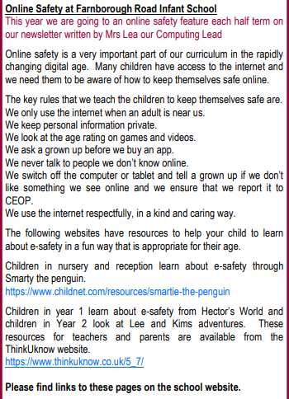
This provides information to parents about the schools expectations with regard to e-safety and gives them the links that they can use at home depending on the keystage of their child. I have also added the links to these resources in the class pages of the school website.
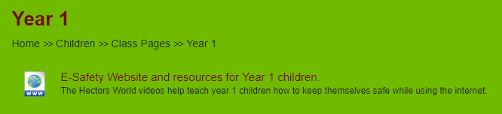
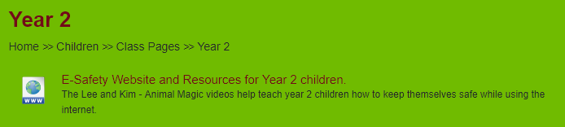
I have added these as well to the e-safety section of the website.
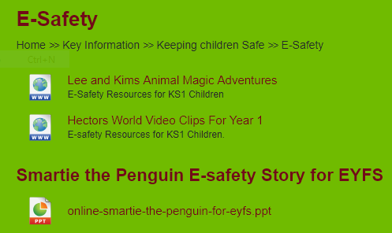
Mrs Taylor also asked me to find information for parents about the online game called fortnight. From the information that I found we added this information to the newsletter about the game and also provided them with the link to an informative poster.
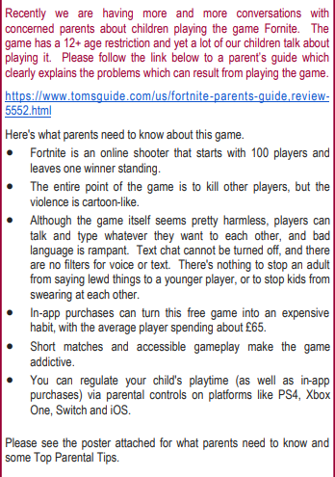
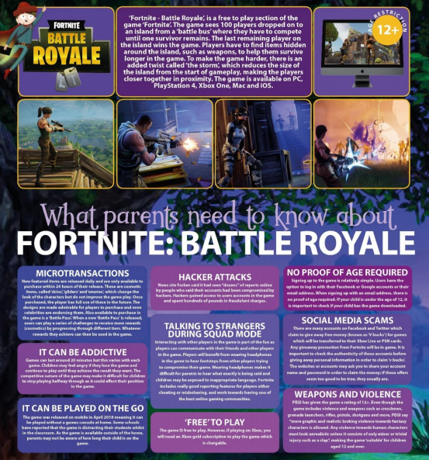
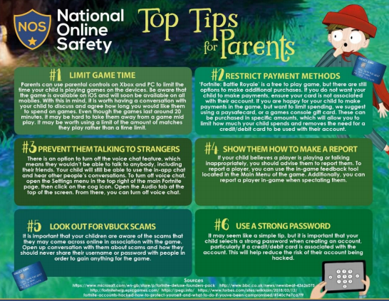
We are planning for safer internet day 2019 which is on Tuesday 5th February which will be included as part of our science and technology week. The theme is “Together for a better internet”
I will also be attending the Online Safety Conference - 13th November

